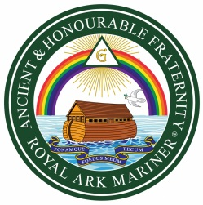 | The Ancient and Honourable Fraternity of Royal Ark Mariners  REQUEST FOR A BROTHER CELEBRATION  This form must be completed using typescript or block letters and sent via the Provincial/District Grand Secretary to:  The Grand Secretary, Mark Masons’ Hall, 86 St. James’s Street, London SW1A 1PL

(Initials) (Surname)
- MMH NUMBER (If known)

- BROTHER

- FORENAMES IN FULL

- MASONIC PREFIX

- PROVINCE/DISTRICT

- LODGE NAME ELEVATED

- LODGE NUMBER ELEVATED

- DATE ELEVATED

- CONSTITUTION (if not English)

- DATE OF CERTIFICATE PRESENTATION Enter Date

- 50 YEARS 60 YEARS 70 YEARS

(Please tick appropriate box)

NAME OF LODGE SCRIBE

SIGNATURE OF LODGE SCRIBE

NAME OF PROVINCIAL/DISTRICT GRAND SECRETARY

SIGNATURE OF PROVINCIAL/DISTRICT GRAND SECRETARY

DATE Enter Date

